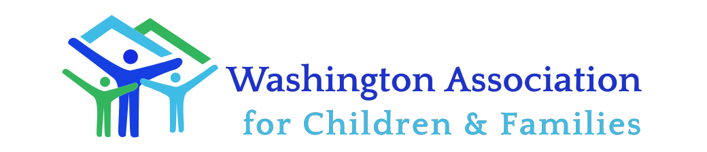

MINUTES

Family Preservation and Support Services Division

June 11, 2020

9:00 to 10:30 AM
Conference Call Meeting
Members attending: Carla Arnold, Charlotte Booth, Karla Cain, Esther Patrick, Amanda Farmer, Sandra Gorman-Brown , Debra Hatton, Molly Phillips, and Kerry Ann Shaughnessy
Staff attending: Jill May and Linda Conchi

Agenda Item | Discussion | Decisions
- Call to order and May minutes |  | The minutes were approved as written.
- Enhancing the training and QA for the EBPs  - PCIT conference requirement | Notice has gone out regarding a Triple P training this summer. No notice is out yet, but there will also be an IY and PFR training sometime this summer.  Charlotte asked the group if they heard from Naomi Perry to sign-up for her listserv. There will be a speaker series, three online trainings. These will meet the contracted QA requirement to attend a conference every other year. | Let Charlotte or Jill know if you have issues signing people up.
- Executive Director Update  Group process | Jill reviewed how WACF advocates for its members. Any documents to DCYF leadership, the Governor’s office or legislators will only be done with the group’s approval. Members should feel like these meetings are a safe place to discuss issues. It was suggested that there should be an agreement created about working collaboratively, confidentiality, and how we treat each other. | Jill asked that if your agency needs to advocate on behalf of yourselves to give her a heads up.  Jill, Charlotte and Sandra will put together a draft agreement and present to the entire group for approval.
- Return to in-home sessions in July | Taku’s thought is that we would begin to transition to in-person in-home services on July 1st. However, that would depend on what phase a county is in. Additionally, if anyone answered affirmatively to any of the COVID screening questions you would not do an in-person visit. Telehealth would transition to being the exception rather than the rule. There is no decision at this point though. The question remains of how long to do Telehealth with clients who were using it prior to July 1st.
- DCYF proposed budget cuts | The in-home travel rate (new money) is being put up as a possible cut. In addition, the in-home travel rate increase granted in 2017 is also proposed to be cut. What in-home providers could charge for time spent travelling would drop to $32.50 an hour. | Jill requested that members send her a message about the anticipated impact of these cuts to their agency.
- Recommendation to Taku re payment system | Taku said on the call that as providers go back to fee for service, there would probably be a month that providers would have the option to continue to accept the retainer payment, or, if the fee for service billing is above that, to bill for fee for service.  Providers requested that the retainer be in place until the fall. | Taku said he would check with the CFO in finance to see how long the retainer payment will be an option for providers.  Jill will follow up with Jenny and include Taku.
- Adjournment |  | The meeting adjourned at 10:25.

Prepared by Linda Conchi

